RiverArts Festival Plein Air Event
Sunday, August 7, 2022
Haussermann Park
221 Front Street, New Richmond, OH 45157
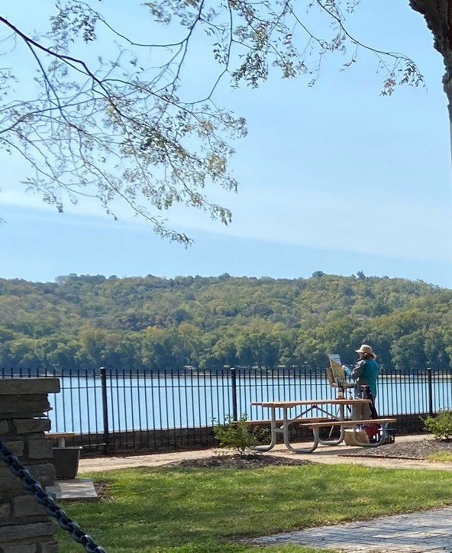
PROSPECTUS
A companion event to the juried RiverArts Festival, held during New Richmond RiverDays. All artists 18 and older are welcome to participate in this outdoor painting event.
Haussermann Park will be dedicated to plein air artists for the day. It is situated above the Ohio River with views of the Front St business district, the hills of Kentucky, passing barges, anchored pleasure boats, the Showboat Majestic, and festival booths.
RiverDays is a weekend long event featuring crafts, food and beverages, a cardboard boat regatta, and music. RiverArts is a complementary juried event, held Sunday only, showcasing fine artists. The Plein Air event is new for 2022.

Open registration begins June 5, 2022
Register online by August 3 at: https://www.nroba.org/riverarts-festival
Schedule
8:30 - 10:30, Check In at Haussermann Park
9 – 4 pm, Painting
4 – 4:30 pm, Judging and Awards
4:30 – 6 pm, Wet Paint Sale
Awards
First Place $150
Second Place $100
Third Place $75
Online payment through PayPal
$20 via PayPal to @thenroba by August 3 (or by mail to RiverArts c/o NROBA, 1248 Bugler’s Sound Circle, Batavia, OH, 45103)
For more information, please contact riverartsfestivalnewrichmond@gmail.com.
Artist Info
Artists must agree to sign, and turn in, the Artist’s Agreement at Check In at Haussermann Park.
Access to Haussermann Park is at the intersection of Front and Walnut Streets. Artists can pull up to the barricades to unload, then find nearby street parking.
We will be stamping canvases and other substrates prior to their use. The Ross-Gowdy House is set up for artist hospitality - refreshments, restrooms, air conditioning. A map of the village will be provided.
All works may be For Sale, or NFS. Only artwork produced on 8/7 may be For Sale. All sales will be between the buyer and individual artists. Frames are recommended. No commission!
Follow us on Insta @riverartsfest and on Facebook @NRRiverArtsFestival

ARTIST AGREEMENT:
- No Smoking / No Pets on grounds
- All works of art must be produced on site. All substrates will be stamped at Check In.
- 90% of the work must be plein air. All painting and drawing media accepted. No photography.
- Artists may paint anywhere in the village but all artwork must contain recognizable elements from the village or views originating from same.

Name: (print) _____________________________________ Signature: ________________________________
Address: _______________________________________ City/State/Zip: ______________________________
Cell number: ______________________________ E-mail: _________________________________________

